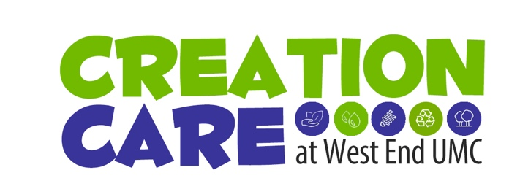

Expansion of Landfill
in Bordeaux

The Issue
Requested expansion (17 acres, another 12 years) of the Waste Management’s Southern Services landfill, located off Briley Parkway and Ashland City Highway, which is in Bordeaux, a predominately African-American community within Metro.
Who Is Affected? How?
Bordeaux has had—and opposed—landfills for more than 50 years. People in the community say they've shouldered the burden for far too long and watched it damage their economy, stall development, slow home sales, and foul the air.
Why Creation Justice?
Landfills are a major source of methane, a potent greenhouse gas that contributes to global warming and ultimately to climate change. Landfill is the least desirable option for disposal of waste due to the high environmental impacts, not only for the methane emission, but also for potential groundwater pollution and aftercare periods of hundreds of years.
Typically, and specifically in this case, landfills are deliberately located in neighborhoods where citizens are poorer and have less political power. This action is an inherently racist, class-based system that environmentally degrades the lives of poorer community members for the benefit of wealthier communities.
Who Has the Power?
Expansion of solid waste facilities is heavily regulated under state law, and those state regulations will dictate Metro’s options. However, Mayor Cooper and other Metro representatives can activate the Jackson Law, which requires local approval for landfills.
If they do invoke the Jackson Law, the council can either veto or approve the expansion. If they do not invoke this option, it could be argued later that the city forfeited its right to object in any future landfill case.
Waste Management’s Statement
The Southern Services facility has been providing critical disposal and recovery services for Construction and Demolition Debris generated by businesses, industries and homeowners in Metro Davidson County and surrounding areas for over 30 years. The 183-acre property includes a 77-acre Construction, Demolition and Debris (C&D) Landfill, an Award-Winning Certified Wildlife Habitat area and a Construction and Demolition Material Recovery Operation that participates with LEED Program Contractors to recover and recycle C&D materials.
Southern Services is a Construction & Demolition Debris Landfill, which is an inert material—the site does not accept municipal solid waste.
The expansion process will likely take several years and will include comprehensive engineering and environmental studies and public engagement with surrounding neighborhoods. We have participated in community zoom meetings to discuss the operations at the site and are committed to operating in a manner protective of human health and the environment.
What Is the “Ask”?
Urge the mayor and council—
- To invoke the Jackson Law
- To hear and honor the affected community of Bordeaux
- To recognize and stop this racist and environmental injustice
- To explore and choose other ways of disposing waste such as waste-to-energy companies that are starting up—one example is the company Indaver in Ireland. https://www.openaccessgovernment.org/what-are-the-alternatives-to-landfill/53719/
Speak to the governor and state legislators—
- About need for prevention of and solutions to our waste problems that do not harm the environment nor inflict injustice on communities of color
To Whom
- The Mayor's office
- The council person of the persons writing a letter
- District 1 Councilman Jonathan Hall, who represents Bordeaux
- Governor Bill Lee
- State legislators

