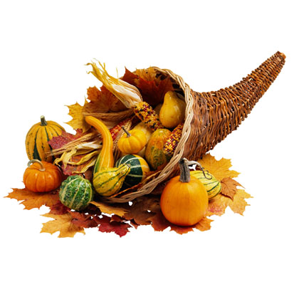 Family Fellowship Festival Fall 2014
Gourmet Market Volunteer Sign-Up

Please help us raise funds for the Family Fellowship Festival by putting on your chef’s hat and cooking one of our wonderful dishes! The proceeds benefit the Play School, Day School, and Children’s Ministries at West End United Methodist Church. This year, we will be offering:

Poppy Seed Chicken Casserole
Margot’s Breakfast Casserole
Pimiento Mac ‘n Cheese
Martha’s Squash Casserole
Southwest Chicken Soup
Chocolate Pecan Pie
Pumpkin Bread
Cranberry Muffins
Martha’s Apricot Oatmeal Bars

Name ____________________________________________________________________ Phone ________________________________

Email Address ________________________________________________________________________________________________________

Child’s Name ____________________________________________ Class _________________ PS or DS or Church (circle one)

________ I will provide ingredients and make casseroles or desserts. (Recipes and pans will be provided and distributed the week of November 17)

________ Number of recipes I will cook. (One recipe makes 4 casseroles/desserts or 8 small casseroles)

________ I will make a cash donation to the Gourmet Market for pans, labels, etc.

________ I will help receive casseroles at the church between 7:30-9:30am
_______ Monday, December 8 _______ Tuesday, December 9

________ I will help staff the table to sell casseroles at the church
Wednesday, December 10 _____ 2:00-4:00pm _____4:00-6:00pm
Thursday, December 11 _____ 2:00-4:00pm _____4:00-5:30pm

Please return this form to the Gourmet Market folder at the Reception Desk by
Wednesday, November 12th.

Questions? Contact Heather McCormack at 618-2042 or hlp82667@msn.com.

